
Neo6502


OLIMEX Ltd.  2 Pravda St., P.O. Box 237,  Plovdiv 4000 BULGARIA | Contact: Mr. Tsvetan Usunov  Email: info@olimex.com  Voice: +359-32-626259, +359-32-267407, +359-32-621270

Welcome – please read!
Welcome to the modern retro computer world, where you can experience the technology from the 70s and 80s, but with a modern spin on it!

This document covers both the Neo6502 and Neo6502pc computer. Detailed specifications and the differences between the two can be found in Appendix A.

Neither of the devices (the Neo6502 and Neo6502pc) are turn-key solutions. Both devices require intermediate electronics and computer use knowledge. While both devices have appeared in social media as an out-of-the-box video game platform, it will require that you read this document, so that you gain the best experience!

Please Note

Regardless of the function you are hoping to utilize the Neo6502 or Neo6502pc, you must be familiar with the process of reprogramming (also known as flashing firmware) the 2MB flash memory utilized by the RP2040. The firmware defines what function the Neo6502 and Neo6502pc will perform. Current firmware available provide a BASIC interpreter (NeoBASIC) that is continues to be developed and improved, an Apple ][ emulator (using the real W6502), and an Oric Atoms. Other firmware is currently being developed, so explore the various user forums, Discord, and Facebook to discover the endless possibilities of the Neo6502 and Neo6502.
Please read the Programming the RP2040 Section!

Both devices require that you obtain or supply the following for proper operation:

Neo6502
- USB-C Power Source (5v, 0.2 amps).
- A USB cable with a USB-A on one end, and the appropriate end that will connect to your computer (used to re-program the RP2040).
- Optional, enclosing case for the Neo6502, available from Olimex.
- Optional, USB-A Flash Drive (highly recommend USB3, ~8 GB).
- Optional, USB Hub (Olimex USB-NeoHub is highly recommended for compatibility).

Neo6502pc
- USB-C Power Source (5v, 1 amp).
- A USB cable with a USB-C on one end, and the appropriate end that will connect to your computer.
- USB-A Flash Drive (highly recommend USB3, ~8 GB).
- USB Keyboard (wired and wireless w/USB dongle are supported).
- Optional, USB Gamepad.

Table of Contents
Welcome – please read! 2
Please Note 2
Table of Contents 3
About the Neo6502 4
Programming the RP2040 5
Prerequisites 5
RP2040 programming for the Neo6502 5
RP2040 programming for the Neo6502pc 6
Current Firmware 7
NeoBasic (codename: Morpheus) 7
Apple ][ and //e Emulation 7
Apple ][ TotalReplay 8
Oric Atmos 8
Appendix A 9
Neo6502 10
Hardware Pictures 10
Neo6502pc 12
Features 12
Hardware Pictures 13
Neo6502pc Specific Hardware Specifications 15
Neo6502pc – Schematic 15
Neo6502pc – 12 GPIO EXT1 Connector 15
Shared Hardware 16
Neo6502pc and Neo6502 – W6502 Bus Connector 16
Neo6502pc and Neo6502 – UEXT Connectors 17
Neo6502pc and Neo6502 – Configuration Switch Block 18
Appendix B – CREDITS and LICENSE 19
This document initially created by 19
Additional authors and Contributors 19
Included documents (superseding) 19
Note to contributing authors 19
Appendix C – Document Revision History 20
Appendix D – About Olimex 21

About the Neo6502
The Neo6502 is an open-source hardware and software standalone modern retro computer with a real W65C02 processor and RP2040 co-processor, 2MB of flash memory, and HDMI video out. This small device works 3-times-faster than any of the other recent 6502 competitors and 30-times-faster than 6502 based machines from the 1980s.

The “Neo” name was used two reasons: First it implies a modern design; Second came from the analogy with the movie The Matrix where the W65C02 lives in virtual world – thinking it has real memory, video and keyboard – however in reality it is all virtual and emulated with the RP2040.

Both the Neo6502 and Neo6502pc are open-source hardware (https://freedomdefined.org/OSHW), with all CAD files and firmware and available to support the future development of software and enhancements to the hardware.

Programming the RP2040

The process of programming the RP2040 is a fairly easy process, however, it has a very specific manner and steps that must be followed to have a successful reprogramming.
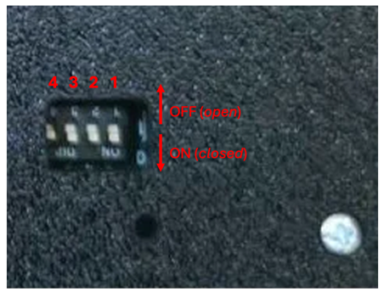
NOTES
- Some emulators require all switches of the configuration switch block be in the on (closed) position.

Prerequisites
- Your computer should be on, and you must be logged in and have the desktop present. Best experience comes with no CPU intensive tasks running on your computer.
- You have the latest version of the firmware that you want to use downloaded to your computer. It is highly recommended that you download the firmware file from the “source of truth” (the developer’s Github repository or website).
A firmware file come in various sizes and names, based on the functionality it performs, however it will always have the uf2 file extension.
- Make sure the Neo6502 device has been powered down.

RP2040 programming for the Neo6502
Required hardware:
- A computer with a USB port and a modern operating system.
- A Neo6502 computer.
- A USB cable with a USB-A on one end, and the appropriate end that will connect to your computer.

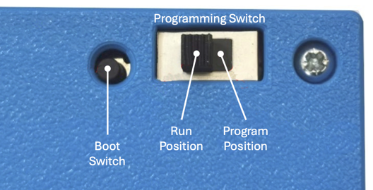
Steps:
- Connect the USB cable between your computer and the Neo6502 USB-A port. If you have a USB hub connected or any other device connected to the USB-A port, please disconnect it during this process.
- Press and hold the "boot" button (bottom left, with the UEXT port on the left and the W6502 bus on the bottom). Ensure you have heard or felt the button depress with a satisfying “click”.
- Turn the power on.
- Release the "boot" button.
- A volume will appear on your computer with the name “RPI-RP2”.
- Copy the appropriate UF2 file to the “RPI-RP2” volume.
- Do not be alarmed, as soon as the copy is finished, the volume will disappear. This indicates that the firmware has been successfully uploaded and programming has begun and will only take a few seconds.
- Reconnect the USB hub and other devices that were removed on step 1.

RP2040 programming for the Neo6502pc
Required hardware:
- A computer with a USB port and a modern operating system.
- A Neo6502pc computer.
- A USB cable with a USB-C on one end, and the appropriate end that will connect to your computer.

Steps:
- Connect the USB Cable between your computer and the Neo6502 USB-C port (with the LCD facing up, the USB-C port on the left).
- Slide the programming switch on the back of the Neo6502pc to the programming position (with the switch facing up and in the upper left corner – move to the right-most position).
- Press and hold the "boot" button (to the left of the programming switch). Ensure you have heard or felt the button depress with a satisfying “click”.
- Turn the power on.
- Release the "boot" button.
- A volume will appear on your computer with the name “RPI-RP2”.
- Copy the appropriate UF2 file to the “RPI-RP2” volume.
- Do not be alarmed, as soon as the copy is finished, the volume will disappear. This indicates that the firmware has been successfully uploaded and programming has begun and will only take a few seconds.
- Move the programming switch back to “run” position.

SUCCESS
Based on the firmware that was just flashed, the Neo6502pc will now operate within the firmware function. Please refer to the documentation that comes with the firmware to know the next steps. The most popular firmware and their next steps are provided in this document.

Current Firmware
The following are accurate as of the August 4th, 2024 revision of this document.

NeoBasic (codename: Morpheus)
Maintained by Paul Robson (paul@robsons.org.uk)
GitHub Repository: https://github.com/paulscottrobson/neo6502-firmware
Obtain the firmware from the repository link

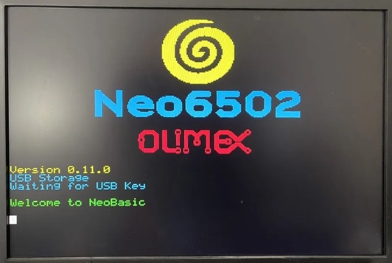
- Within the Github respository, navigate to the releases section (right side)
- Click on the link (release number). This will take you to the releases list.
- Locate and click the zip file to download it.
- Unzip the file.
- Locate the “firmware_usb.uf2” file.
The “firmware_sd.uf2” file is used when you are using the SDCard adapter.
- Follow the directions above to program the RP2040 on page 4.

Please refer to the NeoBasic section for more information.

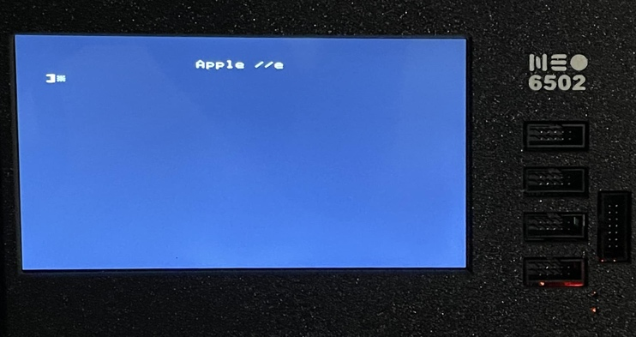
Apple ][ and //e Emulation
Maintained by Veselin Sladkov (veselin.sladkov@gmail.com)
Obtain the firmware from: https://github.com/vsladkov/reload-emulator
The firmware source code is found on the repository; however, it is not compiled into a uf2 file. You can download the uf2 firmware file from Olimex’s FTP site: https://ftp.olimex.com/Neo6502/

- Click the link to open the Olimex FTP site.
- Click and download the “blank_disk_for_apple2e_code_development_apple2e_ProDOS_2_4_3.zip” file.
- Unzip it, and copy the “ProDOS_2_4_3.po” to a flash drive.
- Follow the directions above to program the RP2040 on page 4, with the “apple2e.uf2” file.

You can replace the “ProDOS_2_4_3.po” with other disk images that can be found on the internet. Check out the Apple ][ section on the Internet Archive (https://archive.org/details/softwarelibrary_apple_games) as well as other locations.

Apple ][ TotalReplay
Maintained by Veselin Sladkov (veselin.sladkov@gmail.com)
Obtain the firmware from: https://github.com/vsladkov/reload-emulator
The firmware source code is found on the repository; however, it is not compiled into a uf2 file. You can download the uf2 firmware file from Olimex’s FTP site: https://ftp.olimex.com/Neo6502/
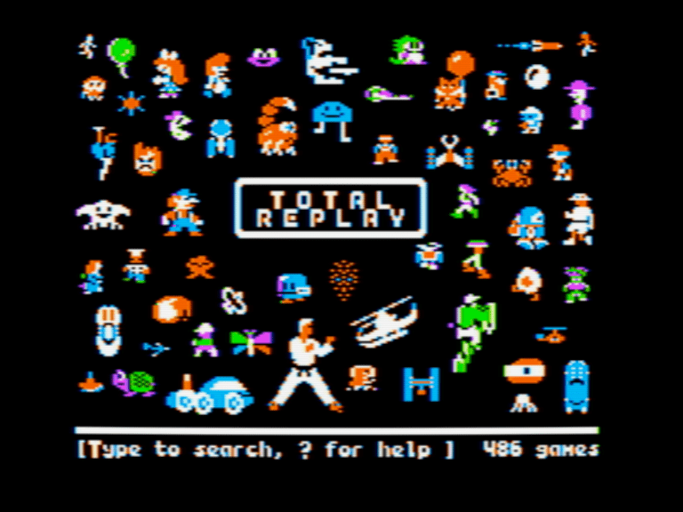
- Click the link to open the Olimex FTP site.
- Click and download two files:
- “Total Replay v5.1.hdv” file.
- “apple2e-5.uf2” file.
- Copy the “Total Replay v5.1.hdv” to a flash drive.
- Follow the directions above to program the RP2040 on page 4, with the “apple2e-5.uf2” file.

If successful, turning on the Neo6502 device, will present you with the TotalReplay title screen. All games can be played with a keyboard and some games support the USB gamepad, your milage by vary.

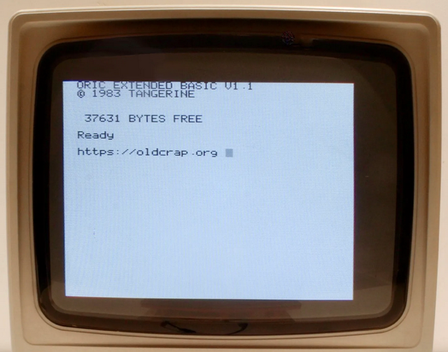
Oric Atmos
Maintained by Veselin Sladkov (veselin.sladkov@gmail.com)
Obtain the firmware from: https://github.com/vsladkov/reload-emulator
The firmware source code is found on the repository; however, it is not compiled into a uf2 file.

You can download the uf2 firmware file from Olimex’s FTP site: https://ftp.olimex.com/Neo6502/uf2/oric_960x540_372MHz.uf2

This is an older version, and no compiled version updated firmware is available as a download, as you must have copies of the Oric ROMs. You will need to compile it yourself or ask folks on social media if a updated compiled version is available.

Appendix A
This appendix offers the detailed specifications for each of the Neo6502 computers and the differences between them.

Feature | Neo6502  Computer | Neo6502pc Computer
Physical W65C02 processor running at 6.25Mhz | Yes | Yes
RP2040 SoC (System on a Chip) w/ 2MB Flash | Yes | Yes
10-pin UEXT connector | 1x | 4x
6502 bus connector | Yes | Yes
Audio mini speaker | Yes | Yes
Audio 3.5mm connector | Yes | Yes
USB-C power supply connector | Yes | Yes
DVI/HDMI connector | Yes | No
USB-A Port | 1x | 3x
4-position configuration slide switch | Yes | Yes
Boot Button | Yes | Yes
One 14-pin external 12 GPIO connector | No | Yes
Programming slide switch | No | Yes
USB-C Programming Port | No | Yes
Build-in LCD display w/ touch panel acting like mouse | No | Yes
Build in LiPo battery w/ charger circuit and battery monitoring | No | Yes
Power on off switch | No | Yes

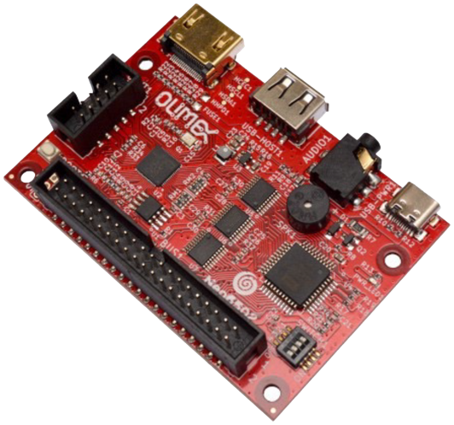
Neo6502
The Olimex Neo6502 was the first model released. The main components are a W65C02 and a Raspberry Pi RP2040. The W65C02 runs the machine code (at about 6.3Mhz), with the RP2040 providing RAM, Video and other aspects.

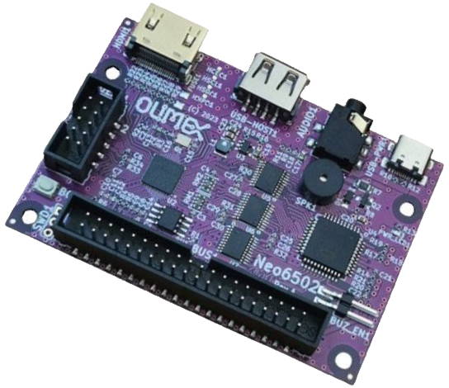
Early adopters had a revision A board (purple), and later the revision B board (red) was released. Both are almost identical, with the exception that the revision A board required a couple of wires connecting pins of the UEXT to the 6502 bus to work properly. Both models come as the board only, with cases available to protect the board.

Hardware Pictures

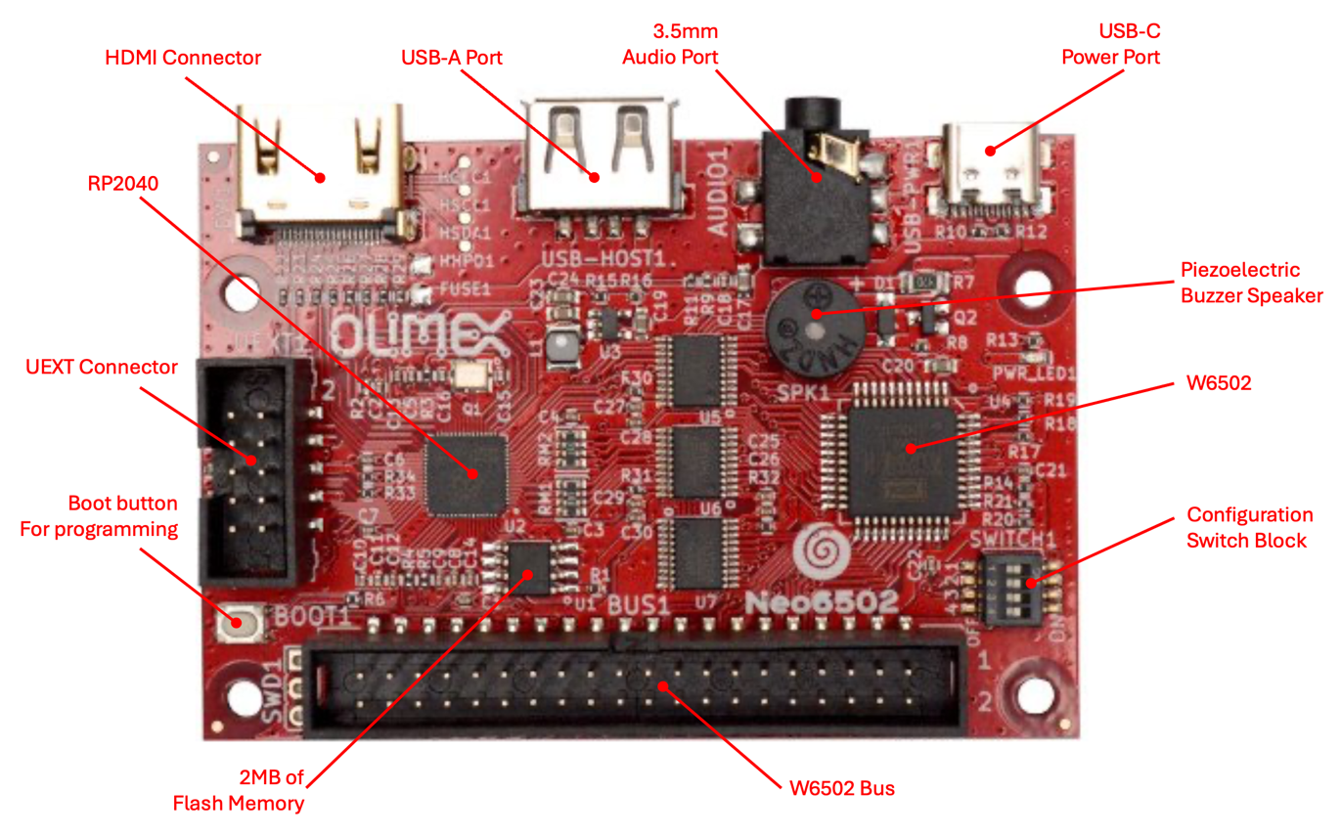

Neo6502pc
The Olimex Neo6502pc is an open-source hardware and software standalone modern retro computer with a real W65C02 processor, RP2040 co-processor, USB host (with 3x USB-A ports), Lipo battery with charger circuit and battery monitoring.
The design goal with Neo6502pc was to create a simple retro-computer with a real 6502 processor that has modern features (provided by the Raspberry RP2040 co-processor) such as HDMI video output, USB ports that support USB keyboards, flash drives for storage, and USB game pad. The RP2040 co-processor emulates the RAM for the W6502 processor.
More Information: https://www.olimex.com/Products/Retro-Computers/Neo6502pc/open-source-hardware

Features
- A real W65C02 processor clocked at 6.25Mhz
- Graphics co-processor RP2040 providing 320 x 240 resolution with 256-color display on HDMI/DVI.
- 32k Graphics RAM for tiles and sprites
- 128 sprites up to 32x32 pixels.
- Multiple tile maps (16x16 tiles, can be double sized)
- High speed drawing features
- Turtle Graphics
- Blitter for high-speed graphics
- Four UEXT interface ports to access a wide range of hardware add ons.
- 1 channel "beeper" sound with SFX library (to be replaced by AY-3-8910 Emulation)
- USB flash drive support for storage w/ optional SD Card support.
- Supports standard USB keyboard.
- Fast structured BASIC with hardware support and inline assembler.
- BASIC can be edited on screen or using a text editor.
- High Speed Integer/Floating point arithmetic
- Huge open-source community that has written documentation, provided samples, and code including games.
- Cross development support
- Accurate cross platform emulator for Windows/Mac/Linux, only requires SDL2
- Serial link to PC for Cross-Development
- Program in PASCAL using Mad Pascal compiler
- Program in 'C' using CC65 and LLVM
- USB Mouse and Gamepad support
- BASIC support for Serial, I2C and SPI hardware via UEXT Connector - 64KB linear RAM space for code
- LCD display
- Internal battery backup power supply which allows it to operate up to 3 hours without external power supply
- Three external and one internal USB hosts (internal is connected to LCD touch panel)
- Audio output
- 12 GPIO extension connector
- USB-C for power and internal battery charging.
- Second USB-C for RP2040 firmware programming
- Dimensions 220 x 130 x 35 mm

Hardware Pictures
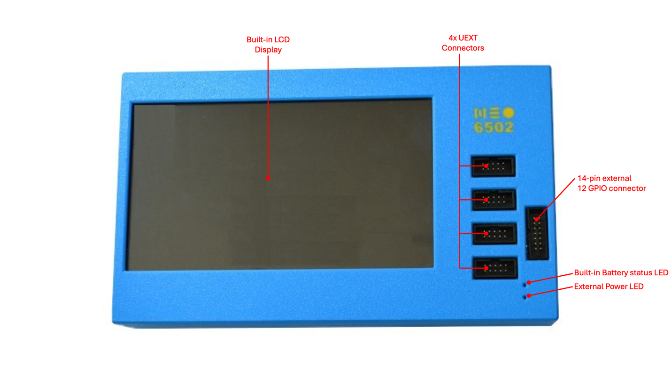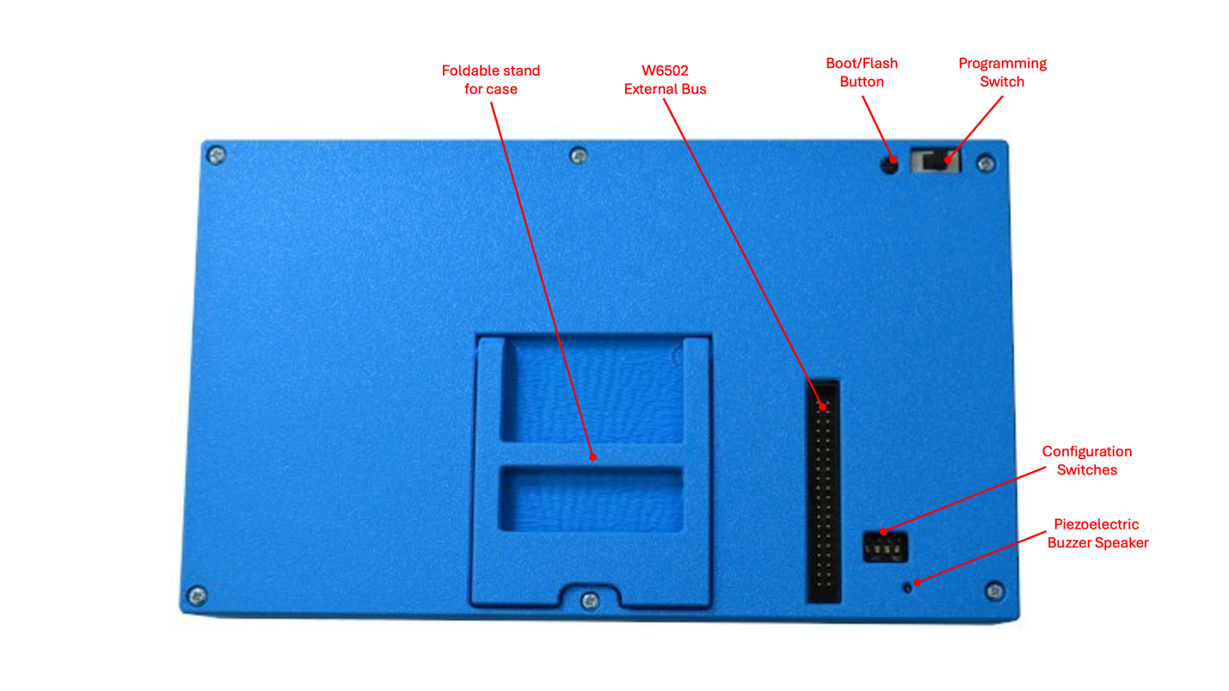

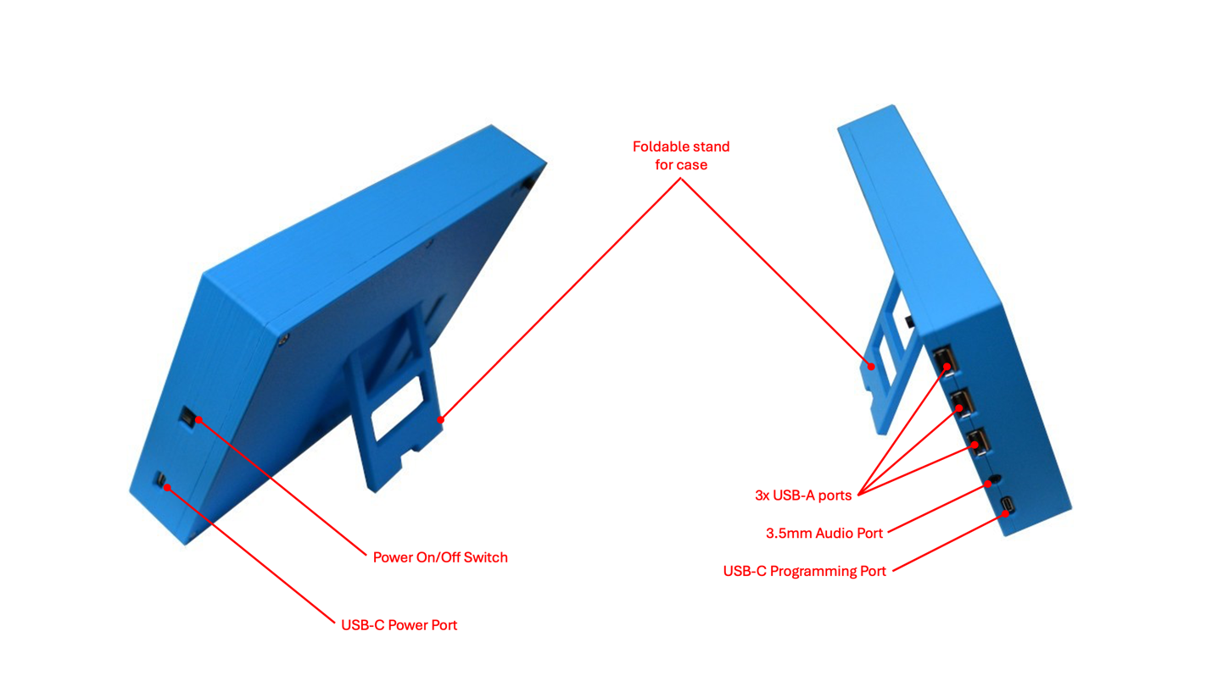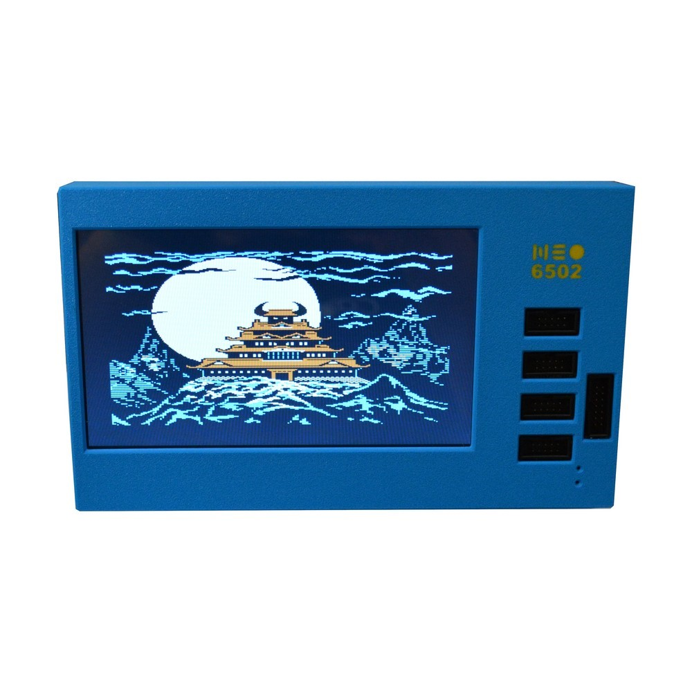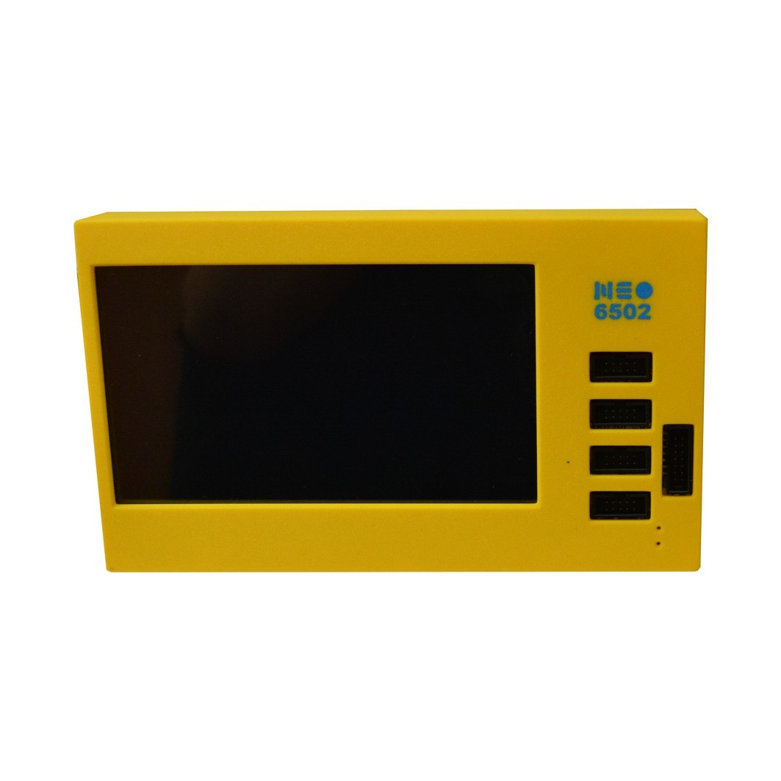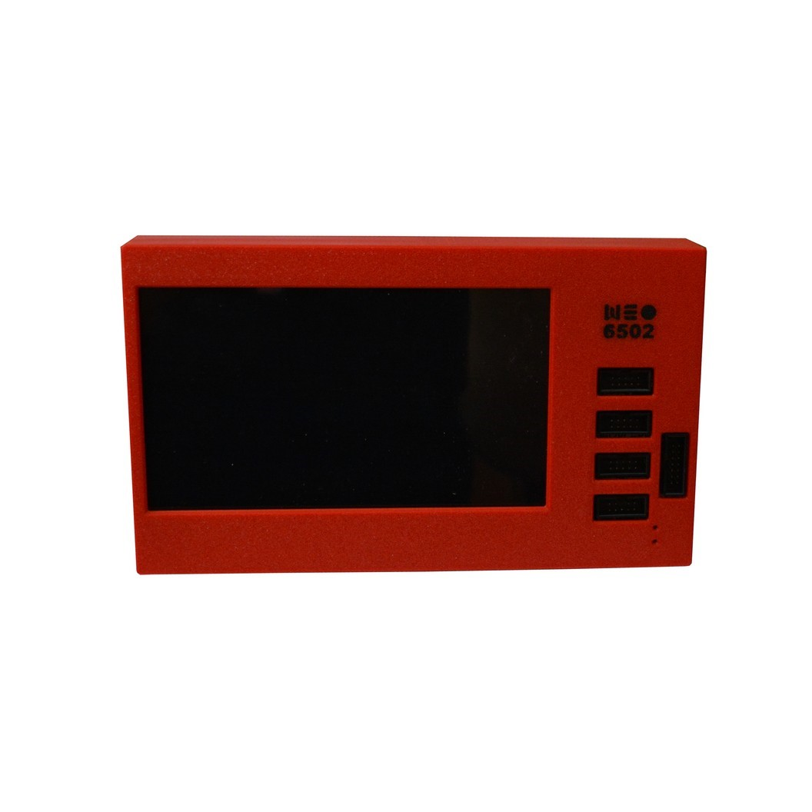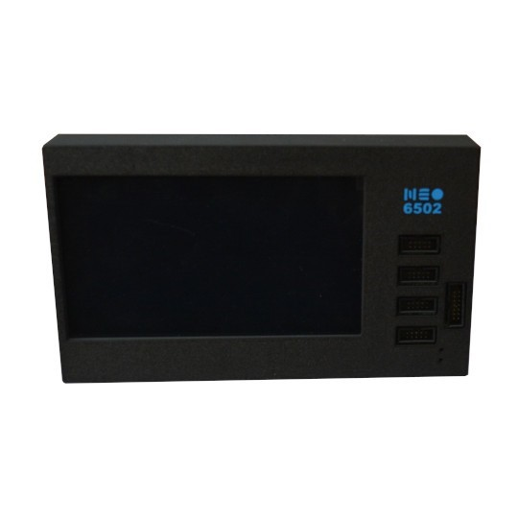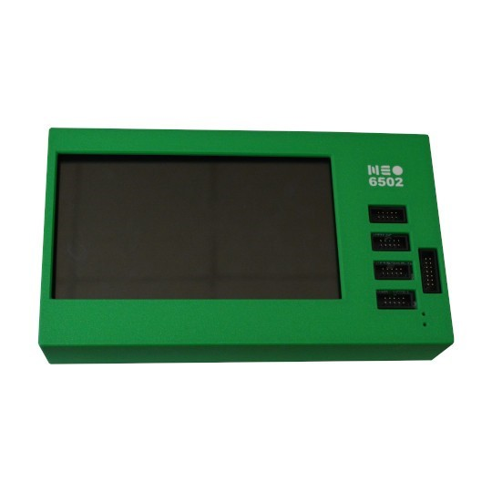

Neo6502pc Specific Hardware Specifications

Neo6502pc – Schematic
The latest schematic for the Neo6502pc is available on GitHub using this link: https://github.com/OLIMEX/Neo6502pc

Neo6502pc – 12 GPIO EXT1 Connector
Neo6502pc has a CH32V003 expander IC which is connected to RP2040 via I2C and can monitor battery charge, the presence of the external power supply and access to the 12 GPIOs via the EXT1 connector:

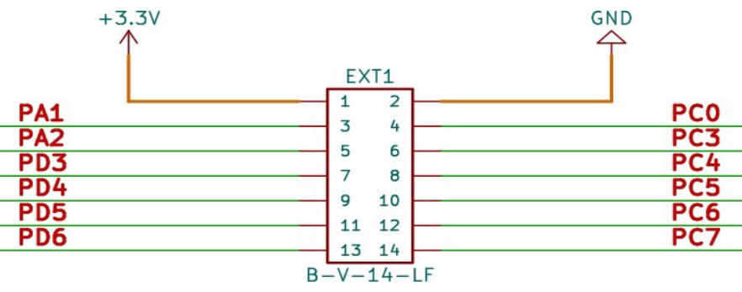
Neo6502pc and Neo6502 – 12-pin GPIO EXT1 connector schematic

Shared Hardware

Neo6502pc and Neo6502 – W6502 Bus Connector
All 6502 signals are available on BUS1 connector for attaching external hardware on it. Signals available:

- +5V
- 3.3V
- GND
- D0-D7
- A0-A15
- PHI2
- R/W
- RESB
- SOB
- MLB
- VPB
- SYNC
- NMIB
- IRQB

Two signals of RP2040 SWDIO and SWCLK are also present for RP2040 debugging, these should not be connected on the external 6502 peripheral boards.

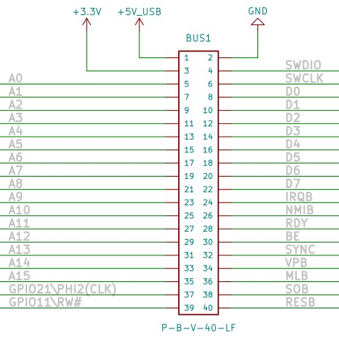
Neo6502pc and Neo6502 – W6502 bus connector schematic

Neo6502pc and Neo6502 – UEXT Connectors
UEXT (Universal EXTension) connectors have the following signals available. All signals are with 3.3V levels.

- +3.3V
- GND
- I2C
- SPI
- UART

UEXT connector can be found in many different shapes, however the connector used on the Neo6502pv uses a UEXT connector that is 0.1” 2.54mm step boxed plastic connector.

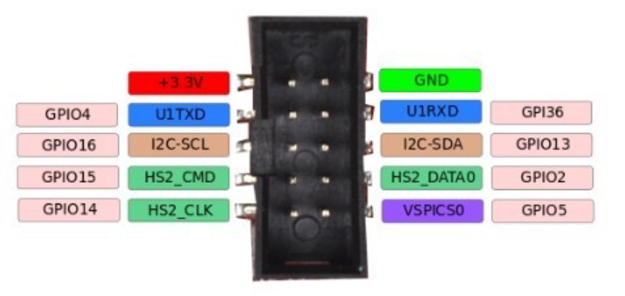
Neo6502 and Neo6502pc UEXT Connector w/signal identification

Olimex has developed number of MODULES with this connector: temperature, humidity, pressure, magnetic field, light sensors, LCDs, LED matrix, Relays, Bluetooth, Zigbee, WiFi, GSM, GPS, RFID, RTC, EKG, sensors and etc.

Neo6502pc UEXT connector is wired to RP2040 GPIOs as follows:

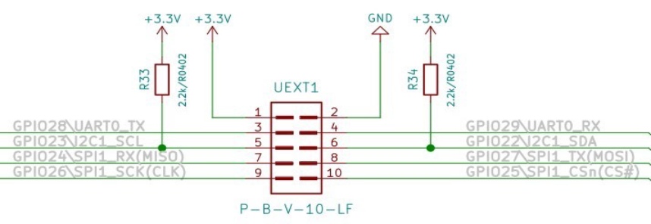
Neo6502 and Neo6502pc UEXT schematic

Neo6502pc and Neo6502 – Configuration Switch Block
The Slide configuration switch can enable/disable the Buzzer, also can connect or disconnect RESB, NMIB and IRQB to RP2040 UEXT signals.
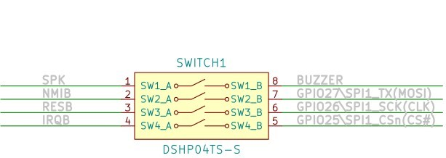
Neo6502 and Neo6502pc configuration switch block schematic
By default Neo6502pc is shipped with all switches in the closed state – enabling the Piezoelectric Buzzer Speaker, and all signals wired to the RP2040. With SW2, SW3 and SW4 enabled, the SPI on UEXT can not be used.

Appendix B – CREDITS and LICENSE
The Neo6502 board, schematics, and firmware are all part of an Open Source project created by Mr. Tsvetan Usunov of Bulgaria.

This document is a open-source copy-left document that is a collection and combination of various other open-source documents and is meant to be a superset of these documents and replaces them. All derivatives of this document must also carry the same open-source copy-left license.

This document initially created by
Greg Jewett
Email: greg_{(at)}ejewett_{(dot)}com
Website: https://sites.google.com/ejewett.com/gregjewett/home

Additional authors and Contributors
- Veselin Sladkov (veselin.sladkov@gmail.com)
- Paul Robson (paul@robsons.org.uk)

Included documents (superseding)
- Neo6502 Documentation, written by Paul Robson and others
- Neo6502 User Manual, written by Tsvetan Usunov.

Note to contributing authors
- Please update the document revision section.
- Please include your name (at minimum) and contact information (optional) above.

Appendix C – Document Revision History
Date | Change Description
2024-08-04 | Initial version

Appendix D – About Olimex

OLIMEX Ltd.  2 Pravda St., P.O. Box 237,  Plovdiv 4000 BULGARIA | Contact: Mr. Tsvetan Usunov  Email: info@olimex.com  Voice: +359-32-626259, +359-32-267407, +359-32-621270

Olimex Ltd is a leading provider for development tools and programmers for embedded market.

The company has 28 years of experience in designing, prototyping and manufacturing printed circuit boards, sub-assemblies, and complete electronic products.

We were established in 1991 in Plovdiv - the second largest city in Bulgaria.

We have extensive knowledge in analog, digital, and microcontroller design, and we offer our own-designed development boards, programmers and emulators for rapid prototyping ARM, AVR, MSP430, MAXQ and PIC microcontrollers.

Olimex is recognized as an approved third-party hardware developer by Texas Instruments Inc., Maxim Integrated, Atmel Inc., NXP Inc., ST Microelectronics Inc., IAR Systems AB, Cirrus Logic Inc., OKI Semiconductor Inc, Energy Micro Inc., and Microchip Inc.

We have over 30,000 active customer accounts who regularly use our services for electronic boards development and prototyping. Our design capabilities are backed by our own PCB prototype production and assembly facility, so all designs made by us are created with design-for-manufacturing in mind - which guarantees that they are optimized for reliability and provide cost-effective solutions for our customers.

The company’s 5,000 sq m. production buildings are situated on our 10,000 sq m. property.

The HDMI port is utilized by the built-in LCD display.
The USB-A port can be used for various USB accessories (keyboards, flash drives, gamepad, etc..) and for the Neo6502 – it serves as the RP2040 programming port (requires a USB-A to USB-A cable).
Requires the USB-Neohub (https://www.olimex.com/Products/USB-Modules/USB-NeoHub/open-source-hardware) the expand the number of USB-A ports available. Additional ports are required to utilize NeoBasic, as you need at minimum a flash drive and keyboard. Unlike the USB-Neohub, not all USB hubs are compatible or supported.

